CENWP-OD-B
10 May 2010
MEMORANDUM FOR THE RECORD

SUBJECT: Dead chinook at Bonneville’s Adult Fish Facility (AFF).

On 09 May at approximately 1100, Project Fisheries removed a dead adult chinook from the PIT detection walkway in the serpentine section of the WA shore ladder. The walkway has a barrier attached to the handrail to prevent fish from jumping and stranding themselves. It is suspected that the fish made it through a very narrow gap at the edge or jumped over the handrail. Information collected is provided below:

- Species – Chinook
- Origin – Unclipped
- Length – 74 cm
- Sex - Female
- Weight – Unknown
- Marks and Injuries – None
- Time of Death – Unknown
- Future and Preventative Measures – None
- Other – University of Idaho provided assistance to check for tags and there were none present.

09 May 2010 Dead Chinook.

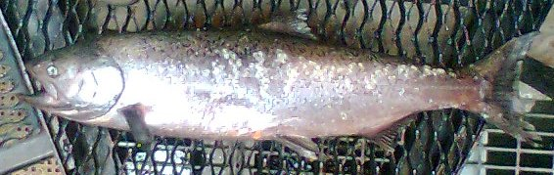

Bonneville Fisheries

